**Goal**

Develop a Database to analyse & visualize Hotel Booking Data

**Requirements**

Build a visual data story or dashboard using Power BI to present to your stackeholders.

* “ Is our Hotel revenue growing by year ? “
* We have two hotel types so it would be good to segment revenue by hotel type.
* “ Should we increase our parking lot size? ”
* We want to understand if there is a trend is guest with personal cars.
* “ What trends can we see in the data? ”
* Focus on average daily rate and guests to explore seasonality.

**Data Analysis Project Pipeline**

1. Build a Database
2. Develop the SQL Query
3. Connect Power BI to the Database
4. Visualize the data
5. Summarize Findings

**Hotel Revenue Analysis Report Using Power BI**

**Overview**

This report provides an in-depth analysis of hotel revenue data for the years 2018, 2019, and 2020 using Power BI. The analysis integrates multiple datasets, including hotel bookings, market segments, and meal costs, to generate insights into revenue trends, booking patterns, and resource utilization.

**Data Sources**

1. Yearly Data Sheets (2018, 2019, 2020):

Columns: hotel, is_canceled, lead_time, arrival_date_year, arrival_date_month, arrival_date_week_number, arrival_date_day_of_month, stays_in_weekend_nights, stays_in_week_nights, adults, children, babies, meal, country, market_segment, distribution_channel, is_repeated_guest, previous_cancellations, previous_bookings_not_canceled, reserved_room_type, assigned_room_type, booking_changes, deposit_type, agent, company, days_in_waiting_list, customer_type, adr, required_car_parking_spaces, total_of_special_requests, reservation_status, reservation_status_date, Discount, cost.

1. Market Segment Sheet: Information about different market segments.
2. Meal Cost Sheet: Details about meal costs.

**Data Integration**

* The data from the yearly sheets was consolidated into a single dataset using SQL, which was then joined with the market segment and meal cost data.

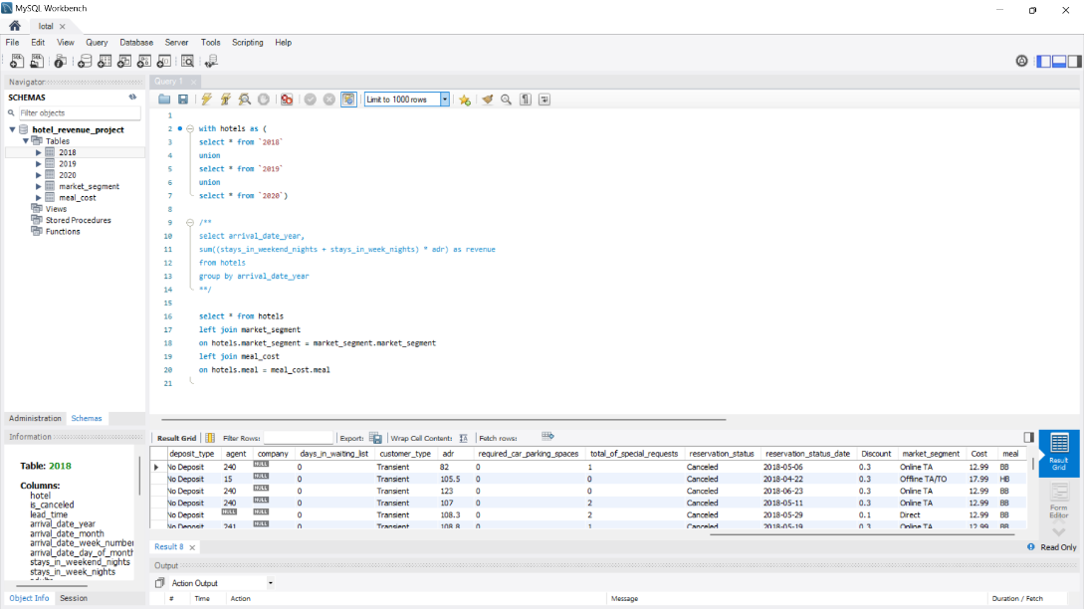

* A new column named "revenue" was created in Power BI using the formula: ([stays_in_weekend_nights] + [stays_in_week_nights]) * ([adr] * [Discount]).

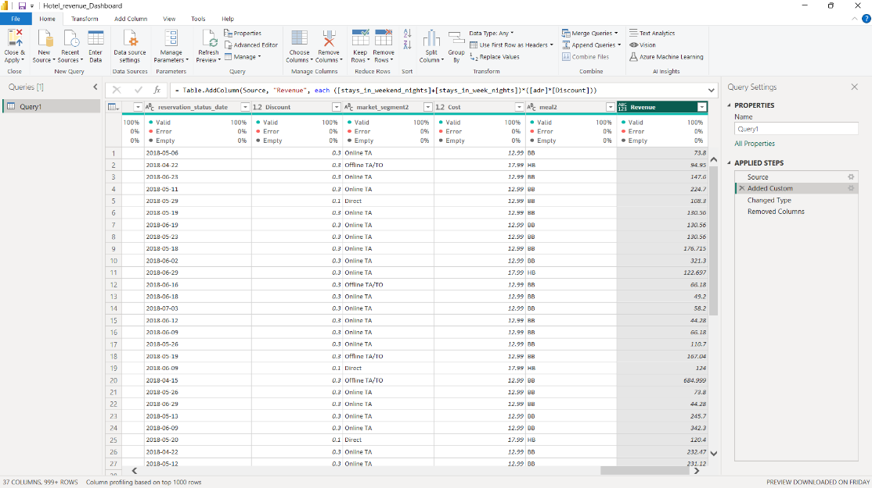

**Power BI Dashboard Elements**

1. Sum of Revenue Card: Displays the total revenue of $10.23M.
2. Average ADR Card and Line Chart: Shows the average ADR (Average Daily Rate) with a line chart representing the sum of ADR by reservation date starting from 2018.
3. Total Nights Measure: Calculates total nights stayed by summing stays_in_week_nights and stays_in_weekend_nights.
4. Total Nights Card and Line Chart: Displays total nights with a line chart showing reservation date by total nights starting from 2018.
5. Average Discount Card and Line Chart: Shows the average discount percentage with a line chart representing the sum of Discount by reservation date starting from 2018.
6. Car Spaces Card and Line Chart: Displays the required car parking spaces with a line chart showing reservation date by required car parking spaces starting from 2018.
7. Slicers:
   * Reservation Status Date (between style) starting from 01/01/2018.
   * Hotel (vertical list style).
   * Country (dropdown style).
8. Revenue Line Chart: Shows the sum of revenue by reservation date starting from 2018.
9. Donut Chart: Displays sum of revenue categorized by hotel type (City Hotel and Resort Hotel).
10. Matrix:
    * Rows: Reservation status date (years), hotel.
    * Values: Revenue, parking percentage (measure created as SUM(Query1[required_car_parking_spaces]) / [Total Nights]).

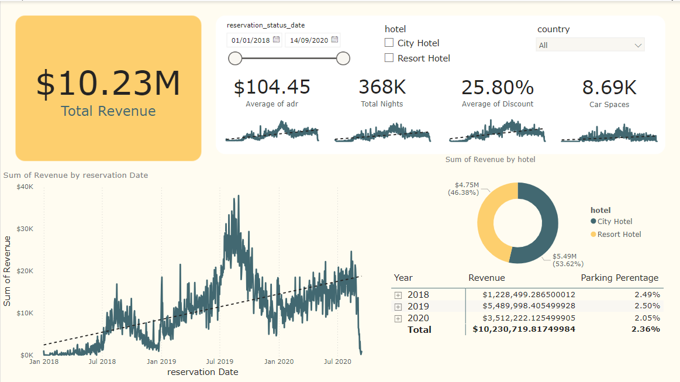

**Key Insights**

1. **Hotel Revenue Growth:**
   * Revenue showed fluctuations over the years.
   * Peak revenue was in August 2019 at approximately $40k.
   * Revenue dropped to around $5k in January 2020 but rose again in summer (August and September 2020) to nearly $23k before dropping towards the end of 2020.
2. **Parking Lot Size:**
   * The parking percentage remained consistent at 2% across all three years, indicating no immediate need to increase parking lot size.

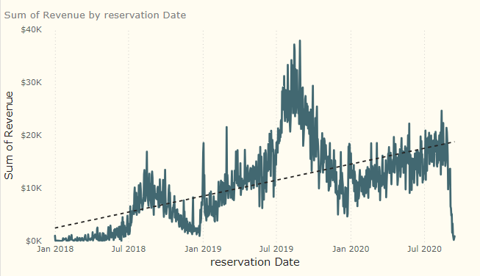

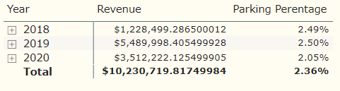

1. **Trends:**
   * High revenue, reservation nights, and hotel visitors are observed during the summer months (July, August, September).
   * Seasonal trends show a significant increase in hotel activity during summer.

**Conclusion**

The Power BI dashboard provides a comprehensive view of hotel revenue and booking patterns, highlighting key trends and facilitating data-driven decision-making. The summer months are critical for revenue and bookings, and the consistent parking percentage suggests the current parking facilities are adequate. These insights can guide strategic planning and resource allocation for hotel management.